# OBJECTIVE:

Build a python code,Assume u get a temperature and humidity values (generated with random functions to a variable)and write a condition to continuously detect alarm in case of high temperature.

# CODE:

Import random while(True):

temp=random.randint(10,99) humid=random.randint(10,99) print(“current temperature:”,temp) print(“current humidity:”,humid,”%”) temp_ref=37

humid_ref=35

if temp>temp_ref and humid<humid_ref; print(“Sound alarm”)

else:

print(“Sound off”) break

# OUTPUT:

Current temperature:86 Current humidity:16% Sound Alarm

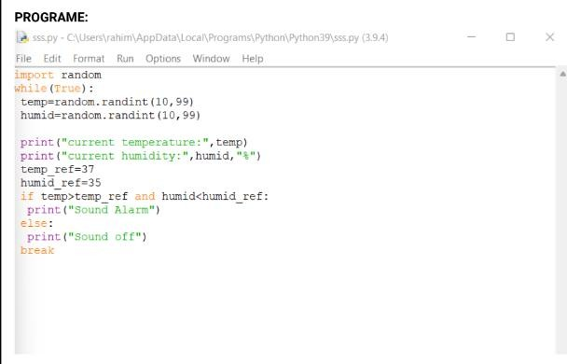

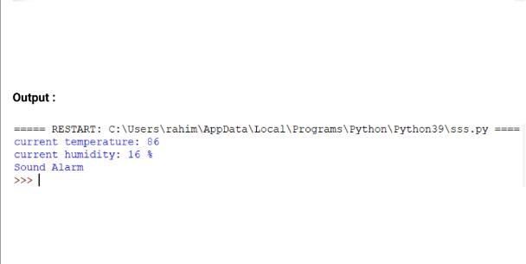Output: